Chapter 8: Statistics and probability
Worksheet B

1 Describe the likelihood of the following events using the words impossible,
unlikely, even chance, likely or certain.

a Thursday will be the day after Wednesday. _______________

b Winning the lottery if you do not buy a ticket. _______________

c Obtaining an even number if a fair 6-sided die is rolled. _______________

d Selecting a blue jelly bean from a packet of coloured
jelly beans. _______________

e Obtaining a number greater than 1 if a fair 6-sided
die is rolled. _______________

2 Match each description (a to f) with its corresponding spinner (A to F).

A B C
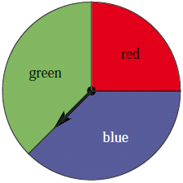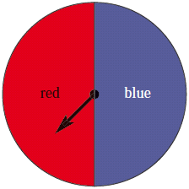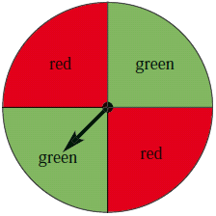
D E F
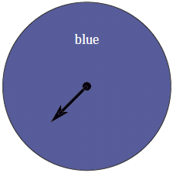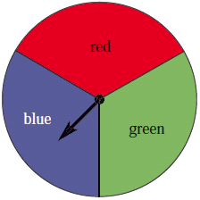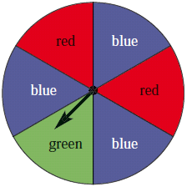

a Blue, red and green are equally likely.

b Red and green both have an even chance.

c Green and blue are equally likely; red and blue are not equally likely.

d Blue, red and green are all possible, but no two colours are equally likely.

e Blue is certain.

f Red and blue both have an even chance.

3 A fair 6-sided die is rolled.

a List the sample space. __________________________________________

b Find the probability of rolling a 5. ____________________

c Find the probability of rolling an odd number. ____________________

d Find the probability of rolling a number greater than 2. ____________________

4 A bag of marbles contains 3 green marbles, 2 red marbles and 5 blue marbles.
A marble is chosen at random. Find the probability that:

a a red marble is chosen. Give your answer as a fraction. _____________

b a blue marble is chosen. Give your answer as a decimal. _____________

c a green marble is not chosen. Give your answer as a percentage. _____________

5 When playing with a spinner with the numbers 1 to 4 on it, the following numbers are spun.
3, 4, 1, 3, 2, 4, 3, 2, 4, 1

a What is the experimental probability of getting a 4?

________________________________________________________________

b What is the experimental probability of getting a number less than 3?

________________________________________________________________

c Based on this experiment, how many times would you expect to get a 4 if you spin 100 times?

________________________________________________________________

